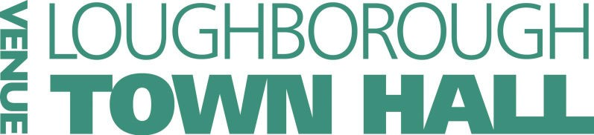
Show in a Week 2026 Application Form
Please clearly indicate which workshop you would like to book.
Week 1 - Oliver ; 20th—24th July
Age 7-17 yrs □ Performance Workshops
Week 2 - The Little Mermaid ; 27th –31st July
Age 7-12 yrs □ Performance Workshops Week 3 - Legally Blonde ; 3-7th August Age 12-17 yrs □ Performance Workshops Week 4 - Aladdin ; 10-14th August
Age 7-12 yrs □ Performance Workshops
Your details
Name of child………………………………………………………………….. Address:…………………………………………………………………………….
……………………………………………………………………………………………. Postcode:………………………………..…D.O.B………………………….. Age (as of 29th July 2026)………...yrs………...months Name of parent/guardian…………………………………………….. Tel No:…………………….Emergency Tel No………………………... Email:………………………………………………………………………………….. Your Friends
If you would like to be in the same group as a friend or brother / sister, please write their names below. We can’t promise this but we will try. Please be aware that groups are split according to age
…………………………………………………………………………………………………
………………………………………………………………………………………………...

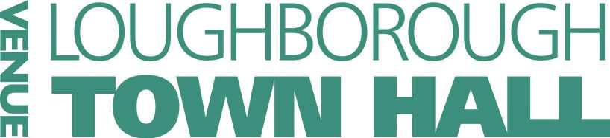

For the participating child to complete — This can be written or drawn, or even both!
Please tell us why you would like to take part in Show In A Week 2026:
………………………………………………………………………………………………
………………………………………………………………………………………………
………………………………………………………………………………………………
………………………………………………………………………………………………
………………………………………………………………………………………………
………………………………………………………………………………………………
………………………………………………………………………………………………
.................................................................................
.................................................................................
.................................................................................
.................................................................................
.................................................................................
.................................................................................
.................................................................................
.................................................................................
.................................................................................
.................................................................................
.................................................................................
.................................................................................
.................................................................................
.................................................................................

Note for the parent/guardian of the participating child:
Should your child have any access or support needs, we will contact you to discuss your child’s individual require-ments and the potential limitations of the building. If you need any guidance or advice then please contact our Box Office on 01509 231 914.

Does your child have any particular needs or access issues that may require additional support? This includes any medication/allergies etc.
(Please detail:)
……………………………………………………………………………………………
……………………………………………………………………………………………
……………………………………………………………………………………………
……………………………………………………………………………………………
……………………………………………………………………………………………
……………………………………………………………………………………………
……………………………………………………………………………………………
…………………...............................................................


Payment
Payment can be made either in person at the Town Hall Box Office, or over the phone via 01509 231914,
TOTAL AMOUNT TO BE PAID: £……………………… Fees: £140 per child
Please note that we require one application form and payment
per child to confirm a booking.

What to do next….
Please send completed forms, with payment, by post or in person to:
Show In A Week 2026 Loughborough Town Hall Market Place Loughborough
LEICS LE11 3EB

Alternatively you can email your application to box.office@charnwood.gov.uk and we will then contact you to arrange payment.
Once a place has been confirmed for your child, a confirmation of
that place will be sent to you.
PLEASE NOTE: The closing date for applications is Friday 24th July 2026, and applications will be dealt with on a first come, first served basis. We advise early booking as these workshops often sell out in advance.
Full Information Packs for Show in a Week will be emailed to you approximately 2 weeks before.

Refunds/Cancellations
No refunds are available if a student chooses to leave Show In A Week once the workshops have begun.
Any cancellations before the start of the sessions are subject
to a £50 cancellation fee.
All adults with access to students during the workshop are fully DBS checked and approved to work with young people.
Students failing to adhere to the Show In A Week
behavioural contract will be excluded from the workshop. Under these circumstances no refund will be given.
Charnwood Borough Council, and by extension Loughborough Town Hall, will not use or process personal information in any way that is incompatible with its notified purposes or in any other way that would constitute a breach of Data Protection law. For full details on the privacy policy please check:
http://www.loughboroughtownhall.co.uk/privacy

