LOUGHBOROUGH TOWN HALL AND MARKETS
APPLICATION FORM SUNDAY 20TH DECEMBER
CHRISTMAS 2020

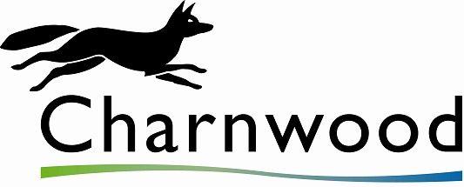

SURNAME:

FORENAME(S):

PREFIX (i.e. Mr, Mrs, Ms, Mx, Mre)
FULL ADDRESS:
(inc. postcode)

CONTACT TELEPHONE NUMBER:
EMAIL ADDRESS:
DATE OF BIRTH: |  |  | NI No.:
EMERGENCY CONTACT DETAILS:
NAME OF BUSINESS:

GOODS TO BE SOLD:

NAME OF OWNER (if different)
ADDRESS OF BUSINESS:
(Inc. postcode) (if different)

DO YOU HAVE A WEBSITE?

DO YOU HAVE ANY SOCIAL MEDIA CHANNELS?

VEHICLE MAKE/MODEL:  (Please note no parking on site, please use local car parking facilities) |  | REGISTRATION NO.:
HOW MANY GAZEBOS DO YOU REQUIRE WITH X2 6FT TABLES INSIDE?

HOW MANY 10FT STALLS DO YOU REQUIRE WITH BUILT IN TABLE AND CANOPY?
DO YOU REQUIRE ELECTRICITY? (We provide a maximum of 240v/16a or 110v/16a) = to a maximum of 32amp.
How many items of equipment do you plan to use? (Please list below?)
(Please note that there is a limited supply)

PLEASE ATTACH 3 PHOTOS OF YOUR ARTWORK/GOODS/PREVIOUS STALLS WITH YOUR APPLICATION AND SEND THEM TO SOCK@CHARNWOOD.GOV.UK

ALL STALLHOLDERS MUST HAVE PUBLIC LIABILITY INSURANCE FOR UPTO £5,000,000.
PAYMENT FOR YOUR STALL MUST BE PAID IN ADVANCE BY 15 /12/2020. PAYMENT IS BY INVOICE.
No refunds will be given unless the markets are cancelled by Charnwood Borough Council.

Please Note: Payment for stalls will be by invoice only and must be paid by 15/12/2020 to attend. Unfortunately we cannot offer refunds once your booking has been completed, unless we cancel the markets for any reason.

By marking the box below, we hereby agree to the T&C’s of the Market Regulations and the COVID-19 T&Cs, copies provided. We also confirm that we have the relevant Public Liability Insurance in place (min £5m).

PLEASE MARK AN ‘X’ IN THE BOX TO AGREE TO THE ABOVE |  | DATE:

Local Authority Registration (FOR FOOD TRADERS ONLY)

Please complete the form below. Please note, food traders must be registered with a Local Authority prior to trading.

NAME OF LOCAL AUTHORITY YOU ARE REGISTERED WITH:

FOOD HYGIENE RATING SCHEME SCORE, FHRS: |  | (Minimum 3) |  | DATE AWARDED:
FOOD HYGIENE CERTIFICATE (tick) |  | NAME ON CERTIFICATE:
ENVIRONMENTAL HEALTH OFFICER  CHECKED AND GIVEN CLEARANCE: | Signed: (BLOCK CAPS) |  | Signature: |  |  | Date:

Data Protection

For information about how and why we may process your personal data, your data protection rights or how to contact our Data Protection Officer,
please view our Privacy Notice

