Application Form for Artists 
Market Place, Loughborough, LE11 3EB

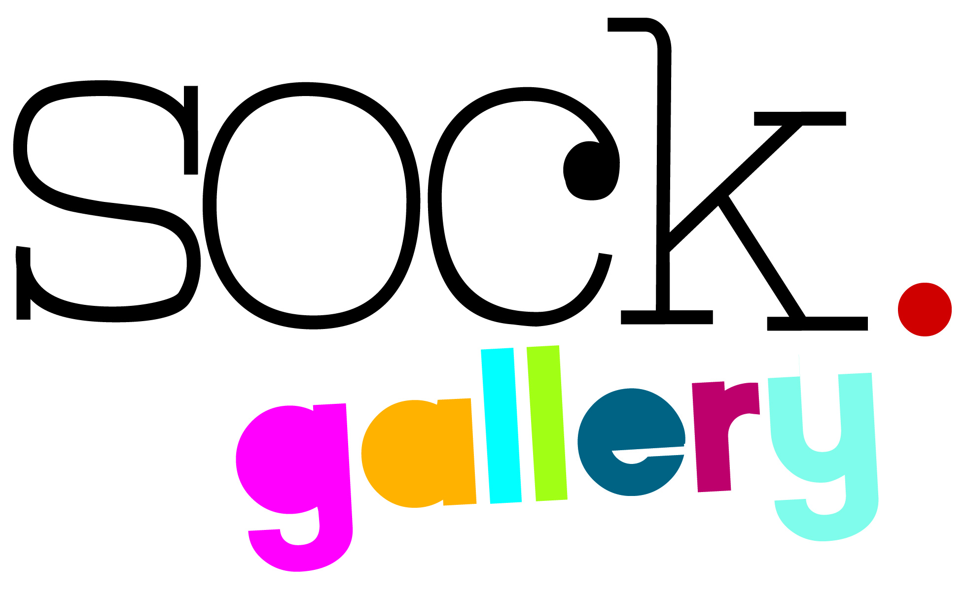
Interested in:

Sock Gallery
Balcony Gallery
Sockette - For Emerging Artists

Are you applying with work that is:
2D
3D
Both

Name of artist (or main contact if group or society):

Name of group or society (if applicable):

Address (all correspondence will be sent here):

Postcode:

Telephone Number:

Email:

Website:

Are you VAT Registered? YES NO
Please provide a brief description of your work:
Include medium and materials used, price brackets and a little about yourself such as relevant experience or qualifications, any fairs/markets/galleries/exhibitions where you have recently exhibited or sold your work.

Images
In addition to your completed application form, please submit four images of your work.
If applying as a group, please include an image from each artist as examples of the type of work you will be exhibiting. Ideally, the images need to show the work that you intend to exhibit, however, if this is not possible, the images must show work similar in style and medium to that which you will be exhibiting.

For each image you supply, please provide the following details:
- Title
- Medium
- Price

Images can be submitted:
- On CD
- By email to sock@charnwood.gov.uk

Are the images that you have submitted of work that you intend to include in the exhibition?
YES NO

Signature: Date:

Please sign above to confirm that the details provided on this application form are correct to the best of your knowledge, and that you or the collaboration of artists own the copyrights to the images you are submitting. You are applying for a sale or return exhibition, Sock Gallery will not be purchasing any artwork.

If you are posting your application form with a CD, please enclose a stamped addressed envelope (with sufficient postage) so that we can return your CD to you.

Your details will be added to Loughborough Town Hall’s Mailing list, please tick here if you do not wish to be contacted

Thank you for your application.

