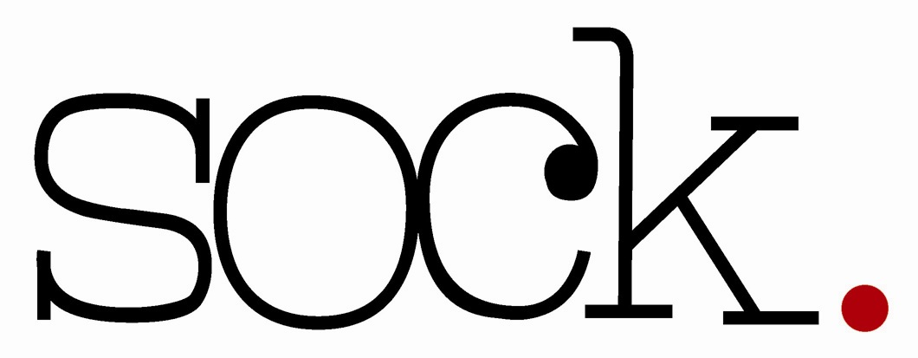
Christmas Art and Craft Fair

Art and Craft Information

Introduction

Situated in Loughborough’s Market Place, Loughborough Town Hall is ideally located as a key building in the thriving Loughborough Town Centre.

Loughborough Town Hall is hosting its second SOCK Christmas Art and Craft Fair. This will take place on Sunday 25th November 2018, 11am – 5pm. On this day is the annual Loughborough Christmas Lights Switch On, when footfall in the town is significantly increased by up to 20,000 people.

Stalls will be situated in the foyer, Sock Gallery and upstairs in the Balcony Gallery.
We are looking for: Visual Arts, Textiles, Ceramics, Glass, Jewellery, Woodwork, Sculpture, Photography and Crafts.
Entrance to the public is FREE.
Deadlines
All applications must be submitted by Friday 21st September 2018. Successful applicants will be notified by Friday 28th September 2018. Any applications received after this date will not be considered. Applicants must download and complete the application Form at www.loughboroughtownhall.co.uk/sock/gallery which can then either be emailed, posted or handed in at Loughborough Town Hall, along with 4 images of your work.

Selection Process
Submissions are judged by an independent panel to ensure the best range and quality of work is displayed.
As well as the requirement to select a wide range of work, the panel have specific selection criteria which include:
- Quality of the work (technical skill)
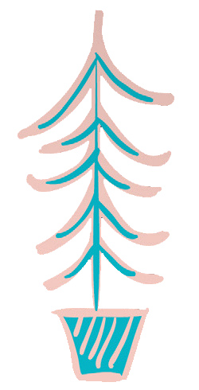

- Originality of work (ideas behind the work)

- Products that are likely to sell
- Work that is well presented

Fees
The cost of a stall is £30.00

Stallholders will receive:
- A 6ft trestle table (approx. 178cm long x 63cm wide). Please note due to limited space we do not allow any extra rails to be used alongside your table.
- A table place card with your company name, indicating your pre-allocated stall
- Access to electrical socket if required (must specify on application form)
- Tea, coffee, water and biscuits available throughout the day
- Publicity on the Loughborough Town Hall website and social media channels

Marketing initiatives to promote the Fair will include:
- A page in the Sock Gallery Brochure March/August 2018, 2000 copies printed and Sept 2018/Feb 2019, 2000 copies printed
- Direct mail to customers on the Sock mailing list
- Press release sent to Loughborough Echo
- Posters and flyers displayed locally and within the venue and Sock Gallery
- Dedicated Sock Christmas Fair page on the Loughborough Town Hall website
- Social Media sites Facebook, Twitter and Instagram
- Relevant local and national listings
- Advertising on Facebook
- Banner at the front of Loughborough Town Hall
- A JPEG image for the fair will be sent to stallholders to share as they wish
- A Facebook event will be created on the Sock Loughborough page for stallholders to share
- A listing in the Loughborough Town Hall What’s On Guide Aug 18/Jan 19, 18,000 copies printed and digitally shared to 16.000 subscribers.
- The Christmas Fair for 2017 was included on all Love Loughborough (The Town partnership) Christmas events listings around the town, on poster boards, tourist points, around the Christmas tree in the centre of town and printed in their events brochure, which is distributed throughout Charnwood. They also created a Facebook event on their page for the Christmas Fair. We hope to be included again this year in Love Loughborough’s listings.
Conditions of acceptance:
- The Fair accepts no liability for damage to or loss of work on display or in transit
- During the Fair, ALL artists will be responsible for taking payment for any pieces sold

Please don’t hesitate to contact us if you have any questions. We look forward to your application!
Page 3 of 3
Page 3 of 3


